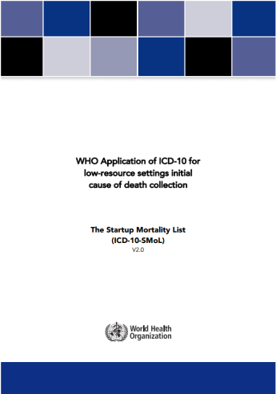
Start-Up ICD-10 Mortality List (SMoL) for DHIS2
Introduction
The Start-Up Mortality List (SMoL) has been designed to be in line with the International Classification of Diseases version 10 (ICD-10), and informs setting public health priorities and tracking progress towards national and international targets and goals such as the post-2015 health and development agenda. This list is designed to be a first step towards standardized reporting of causes of death. Countries lacking the capacities to code to ICD-10 3- or 4-digits should use the SMoL. Wherever capacity exists or completeness of reporting is sufficient, the full ICD should be used, ideally in combination with electronic coding tools.
The Structure
The SMoL is based on the ICD general mortality special tabulation list, but it includes categories for maternal and perinatal deaths, and some detail proven useful in GBD. Added detail includes: leprosy; syphilis; dengue; hepatitis B; confirmed tuberculosis; confirmed malaria; benign neoplasms; alcohol; other substance abuse; liver cirrhosis; obstructed labour; maternal haemorrhage; maternal sepsis, prematurity; low birth weight; few malformations; poisoning: alcohol, drug, food. Some of the additions are optional. Atherosclerosis has been removed as it is redistributed in all statistics. Users are free to add additional detail as long as that detail allocated within the framework provided by the categories of this simple mortality Instructions in the SML instruct what to include or exclude in certain categories. These instructions are indicated by the terms “includes” or “excludes”.
Use of the SMoL
The cause(s) of death are reported on a standard WHO medical certificate of cause of death. The underlying cause is coded with the SMoL. Reported causes, age, sex, location and the code of the underlying cause of death are recorded for every individual case. For cases where more than one cause of death is reported, the SMoL selection rules will help to identify the single underlying cause in a way that is compatible with ICD.
Pre-requisites
Implement the WHO medical certificate of cause of death. Physicians are trained in filling in the WHO medical certificate of cause of death. Ideally, a list of causes reported on local death records is compiled (local index or dictionary) and linked to the SMoL. A coding specialist and a separate ICD correspondence list will help to pre-code the local list of terms with the help of the ICD index.
Minimum Variables for Cause of Death Collection

Variables that need to be collected for cause of death information are:
1. Hospital ID 2. Case ID 3. Age (for neonates in hours, infants in months, children and adults in completed years) 4. Sex (male, female, undefined) 5. Causes of death 6. Reason for admission to the hospital after assessment 7. Pregnancy status (pregnant, intrapartum/delivery, puerperium, none) 8. Fetal death (yes /no).

Cause of Death module for DHIS 2.22 Ver. 1.0

The Cause of Death module consists of files of DHIS 2 metadata, as well as a server-side script to enable coding of causes of deaths to ICD-SMoL. More specifically, it includes:

- A tracker program with data elements, option sets, custom data entry form, program rules, program indicators etc.
- A standard report for validation of data.

- A dashboard with data visualizer charts and pivot tables.
- A node.js script that enables coding of the data collected in DHIS.

Latest entries for a Health Facility A1 in District A through Event capture in DHIS2
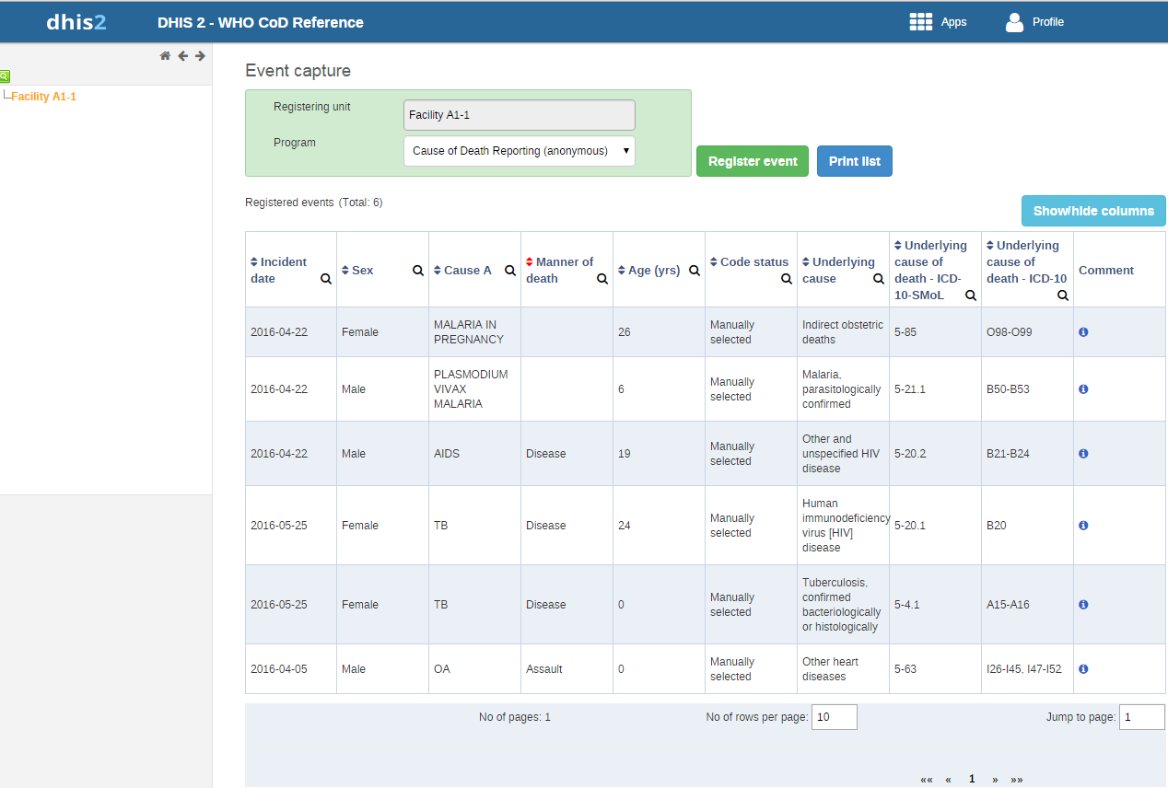

DHIS2 –CoD Features in summary

- Integrates the international standard Medical certificate of cause of death
- Uses the concept of the standard start-up list of causes that is built on existing ICD short list and includes as well causes of relevance to the global burden of disease study
- Allows the application of simplified ICD rules to select the underlying cause of death
- Applies validation checks to avoid data entry errors and blanks
- Enables data visualization via dashboards

Expected outcomes of implementation
- Standard approach used by countries in recording cause of death data in hospitals.
- Comparative outputs from analyses on causes of death data
- Improved local capacity
- National project roll-out is feasible

For more information please contact:
Mr Mark Landry
Regional Advisor
Health Situation & Trend Assessment
WHO, Regional Office for South-East Asia
E-Mail : landrym@who.int
Telephone: +91 11 2330 9287

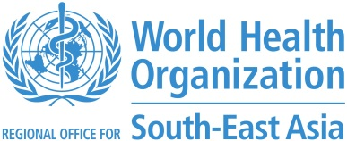
Dr Rakesh Mani Rastogi
Technical Officer
Health Situation & Trend Assessment
WHO, Regional Office for South-East Asia
Email : rastogir@who.int
Telephone: +91 11 4304 0438

